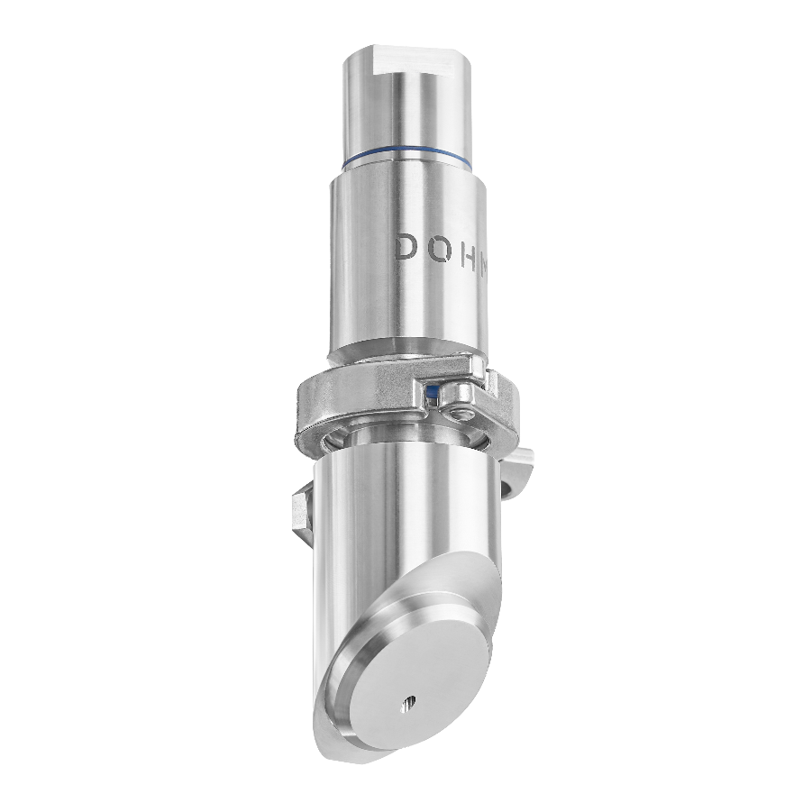

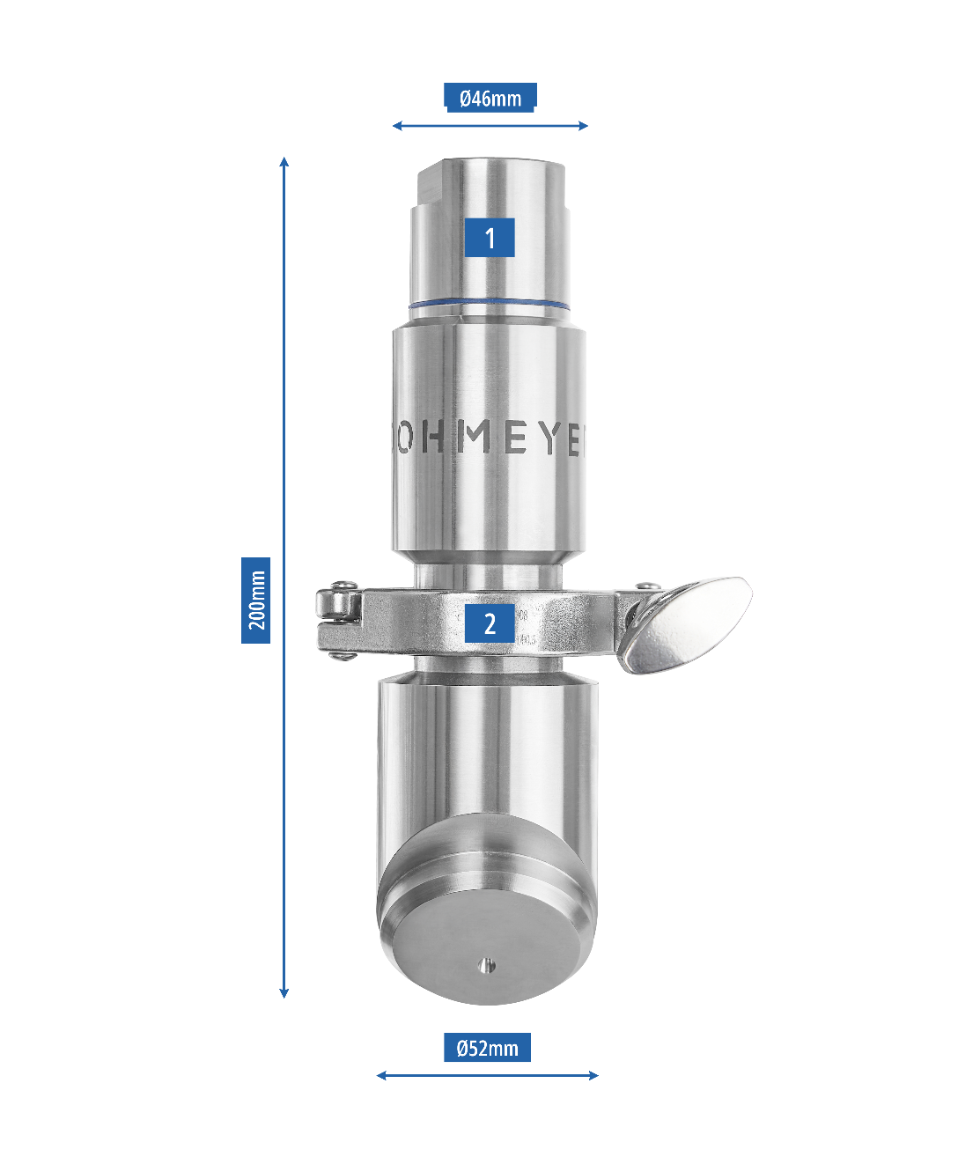

CONSTRUCTION

|  |  |
| --- | --- |
| **BOTTOM INJECTION NOZZLE MODEL 2024** | |
| BODY | Stainless steel AISI 304 |
| PLUNGER | HDPE |
| SPRINGS | Stainless steel AISI 302 |
| FIXATION | Welded to the blender’s body |
| PNEUMATIC UTILITIES | Compressed air with dew point below –30°C must be supplied  Pressure 6bar (min) and 8bar (max) |
| CLEANING | To clean bottom part of the nozzle, unscrew the nut (1) and then remove the clamp (2). When reassembling, first put the clamp back on (2) and then screw the nut back on (1). |

**COOLING MEDIUM**

|  |  |
| --- | --- |
| LIQUID NITROGEN | The supplied LIN must be within the pressure range: 2,3 – 4,1 bar  We strongly recommend vacuum insulated LIN pipeline with venting unit or phase separator.  Control by: customer’s responsibility  Connection: tube Ф10 mm |
| LIQUID CARBON DIOXIDE | The supplied LCO2 must be within the pressure range: 14 – 20 bar  We strongly recommend vacuum insulated LCO2 pipeline with venting unit or phase separator.  Control by: customer’s responsibility  Connection: tube Ф10 mm |